Onboarding Overview
June 12, 2025
9:44 AM

To build a working onboarding package for RJLU Compliance team, where this will be a guide for us to onboard new people. This should as detailed as possible, but kept in a high level.

Consolidated Basic Company Infor

RJL Compliance Onboarding Package
Training Plan and Material

Checklist

Update the team member on RJLU/RJL SharePoint Compliance Page
<<Basic Exemptive Relief Conditions for RJLU.docx>><<Daily Work Schedule for Roman Scherbiuk.xlsx>>

  - Policy / Desk Procedure
    - Annually Update / Always right
  - Working Note/ Training Note / Mostly One Note
    - Not Always Updated, More in detail about how and what to do in different scenario

Checklist
<<RJLU Compliance Onboarding Program.pptx>>
June 26, 2025
12:33 PM

New Hire Basic Setup - Service Now

MAC (Onboarding / Offboarding / Changes)
- Profile Setup/ Email/ Build Access/ Equipment (WFH)/VPN
- Shared Drive/ Shared Mailbox / RJF Domain / RJLU SharePoint Editor
- Netx360/ FactSet/ Dataphile/ Adobe Pro/ Policy Profile/ FINRA Gateway/ Blue Matrix/ Proofpoint/ Box.com/ Smartsheet/ OpenPages/ PowerBI Dashboard/ Canari
- Printer/Camera/ Headset/Personal Drive
- Police Viewer

RJL/ RJLU Introduction - Resources
- RJL Compliance Onboarding Package (Wendy Wang)/ Compliance Org Chart
- RJLU Cross Board Operation
  - Exemptive Relief/ FINRA Weekly Update/ SEC Exam Focus
  - RJLU Departments Overview (Coffee Chats)
- RJLU Market Material
- RJLU Team Structures

Learning
- Smartsheet University https://smartu.smartsheet.com/
- SharePoint

Employee Support - RJ Net - HR Resources

After Start Date
- Fingerprint Package - Request the NRP Fingerprint package from RJL Registration.
- Install Teams on phone
- Sign up for SIE exam and purchase the Kaplan study material

Initial Training
- RJLU Background
- RJLU Compliance Inbox Management
  - Color Code / Flag
  - Email assignment
  - Set Up Alerts

- Netx360
  - Service Center Request

Task Training
- Remediation Investigation Repapering
  - Repapering Process
  - Folder Structure
- Physical Certificates / Low Priced Security

<<Compliance New Employee Welcome Deck - April 2025 EN version.pptx>>

Onboarding HR Stuff
July 14, 2025
5:01 PM

Hiring Manager
- Confirm the offer detail with Ash, then Jason
- Propose the offer detail to HR
- Read and confirm the offer with HR
- Jason and Ash approve it
- Start the MAC on Service Now

Candidate
- Create an account on Taleo
- Background Security Check from HR.
- Accept the Offer
- Complete payroll onboarding process
- Confirm welcome gift
- Enroll in Manulife Group Benefits

Best Practice
July 21, 2025
11:21 AM

Below are some best practice that we recommend

Best Practice: Compliance Email and Inbox Management
- The Compliance inbox doesn't have notifications. Check the inbox every 10-15 mins. Even during meetings, should be able to watch out for new emails.
- Choose your own color category to mark your task
- Flag the email that you are working on/ tracking
- Check the email as complete once the task is completed or the follow ups are all completed.
- Escalate/message the manager for all urgent inquires.
- You can leave email unread as a tool to highlight the assigned emails. But don't leave it unread and uncategorised for too long.
- You can set up email alerts and rule to notify yourself about incoming emails

Meeting invite and Setting up meetings (Look up on the RJnet for this)
- Meeting set up and turn on your camera, set up the background

Offboarding
February 3, 2026
4:48 PM

Offboarding - Get in touch with HR
- On a side note, if Roman resigned, you will need to submit Offboarding ticket in ServiceNow

- SOE in Smartsheet to ensure correct offboarding (including technology, payroll, etc.). Please, make sure to them before the last day of employment.

- Notice of End of Individual Registration or Permitted Individual
- U5
- 100000
115000

- CIRE
- RSE
- Supervision Exam
- Option Exam
- Option and Future Supervision

FA LEADER SHIP TECH IMPRROVEMENT PR

Markham
And St Catharine
Brooklin

Agency cross, unintentional cross
Do a trade review on this
On Netx360 Agency Cross column.

2026 Mid Year Review
April 2, 2026
4:28 PM

Stabilize RJLU Compliance Control
New Tools & Automation
Team growth & enablement
Analytical support for ad-hoc projects
Exams/Audit participation

Meeting Notes
PCG Escalation Series
April 6, 2026
1:02 PM
OK yeah I told him 'cause we clear them everyday so we don't really worry about that part an I'm testing those so while I'm
2026-04-06 1:03 PM

Daily Trade Review
July 22, 2025
3:37 PM

Quality Control for Daily Trade Review

- 2025-07-17 - Ash - Review is complete, but the formatting and notes are not complete
- 2025-07-18 - Roman - Significant data missing from the Pro Client tab (Yuan find out the he was using the account name instead of the FA name. file has been corrected on 2025-07-22)

Email Monitoring
July 22, 2025
3:43 PM

Repapering
July 22, 2025
3:44 PM

  - 2025-07-22

LPS Deposit
July 22, 2025
3:45 PM

We might need to go through each deposit for the past 12 month. Make sure the record is correct.

Trading Restrictions
July 23, 2025
10:23 AM
READ ME
February 20, 2026
12:56 PM

Instructions for Editing Word Files
February 20, 2026 – 12:56 PM
- When making edits to a Word document, always insert changes as a printout to enable the search function.
- Apply modifications directly to the document.
- If you are uncertain about a change, add a comment first to clarify your reasoning or questions.

Low Priced Securities - RSTK - Legend Removal
February 20, 2026
12:47 PM

<<Training Notes - Low Priced Securities - RSTK - Legend Removal.docx>>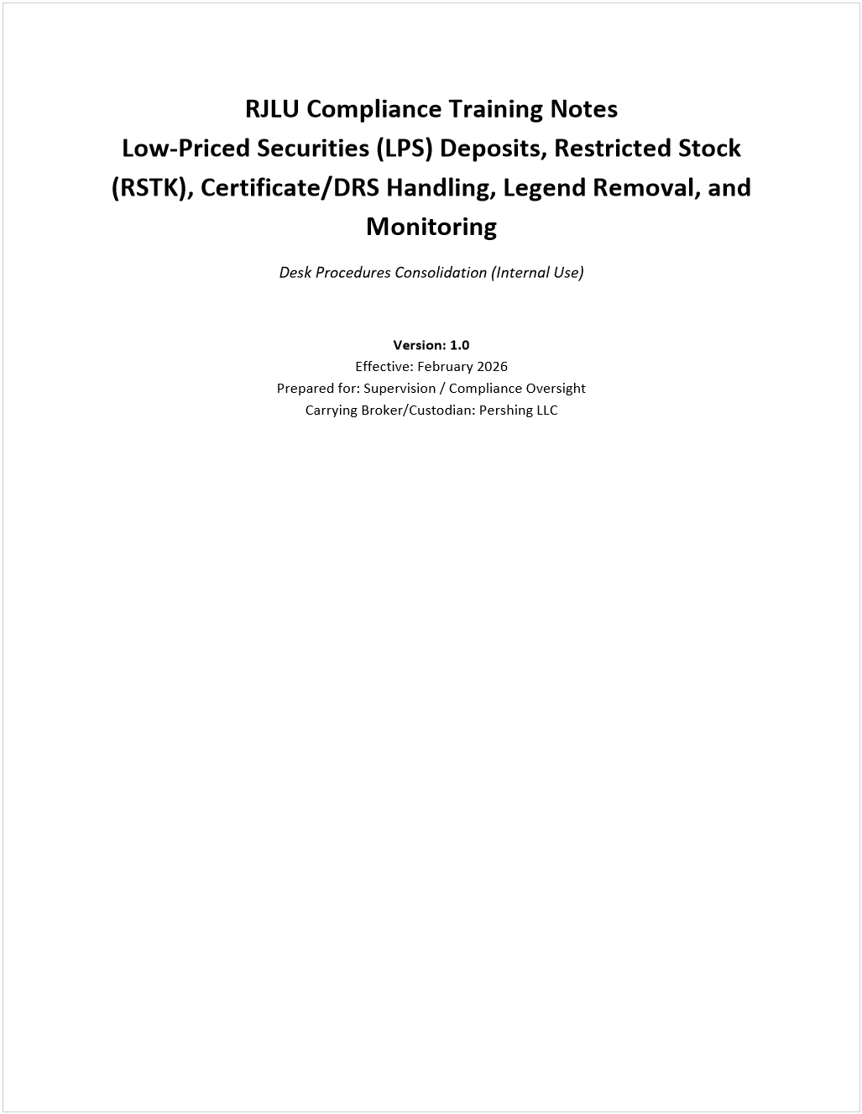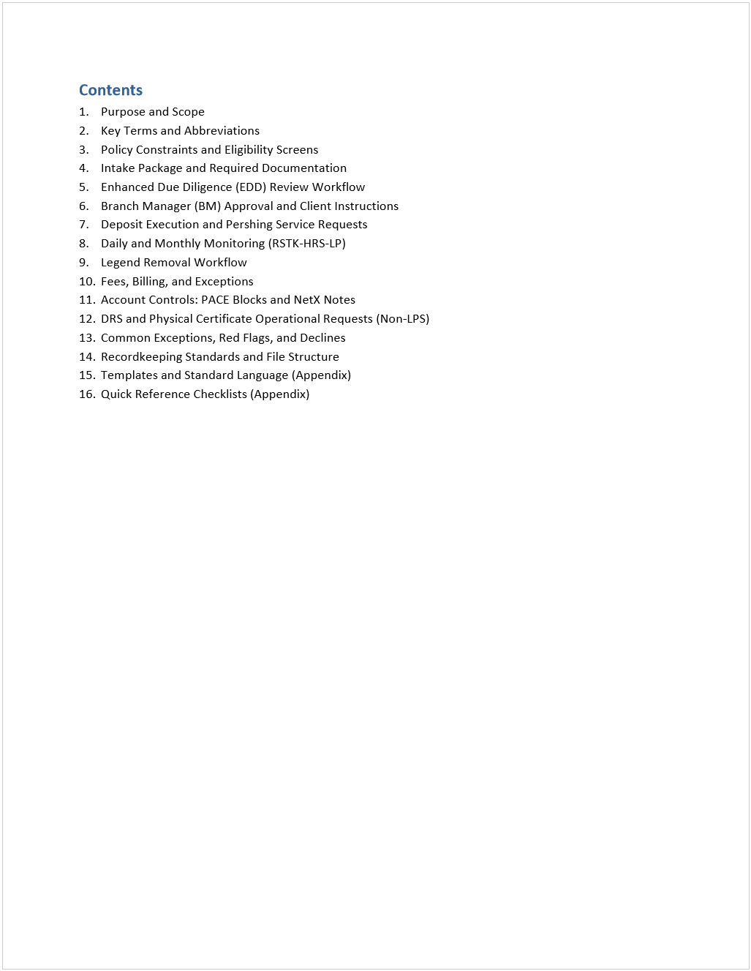

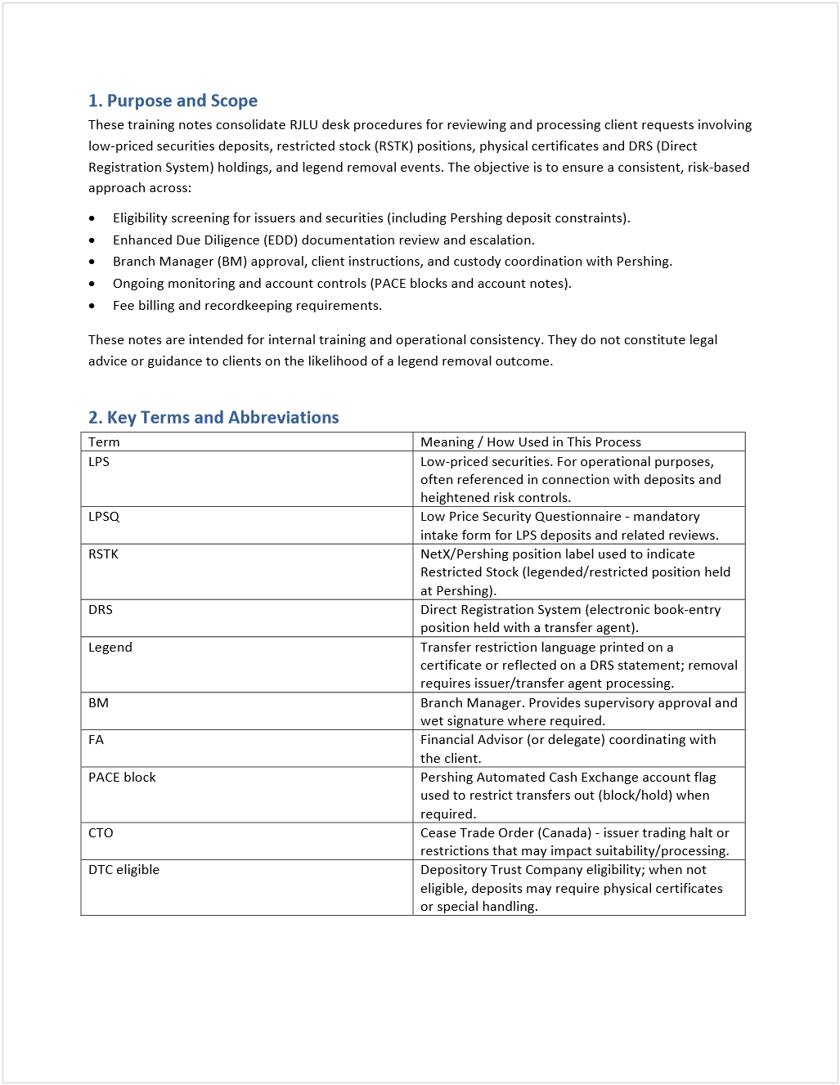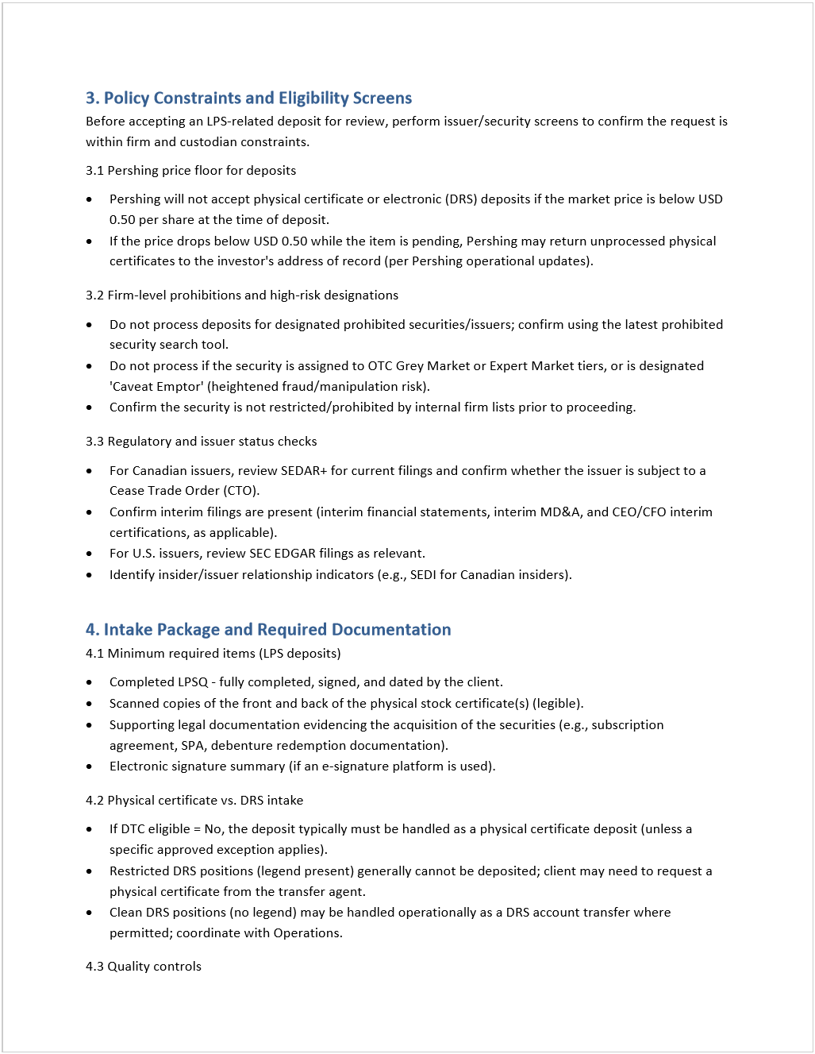

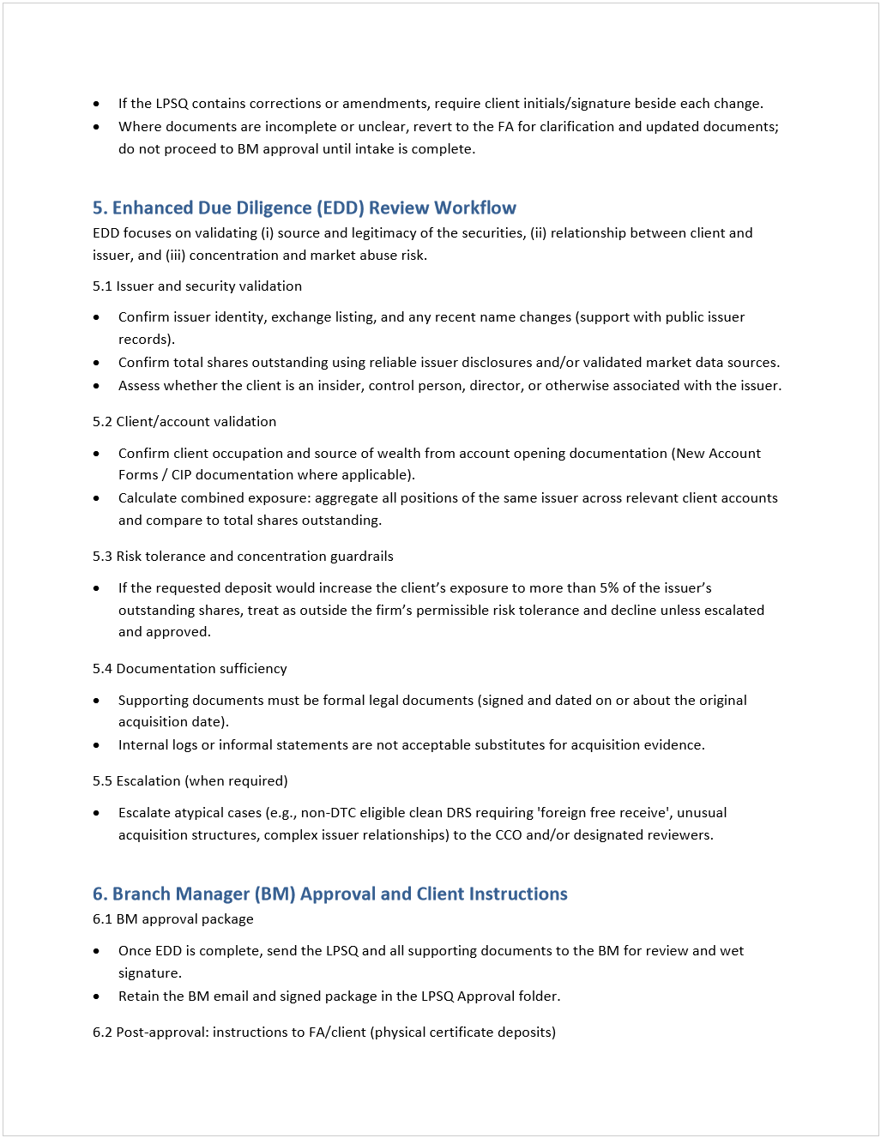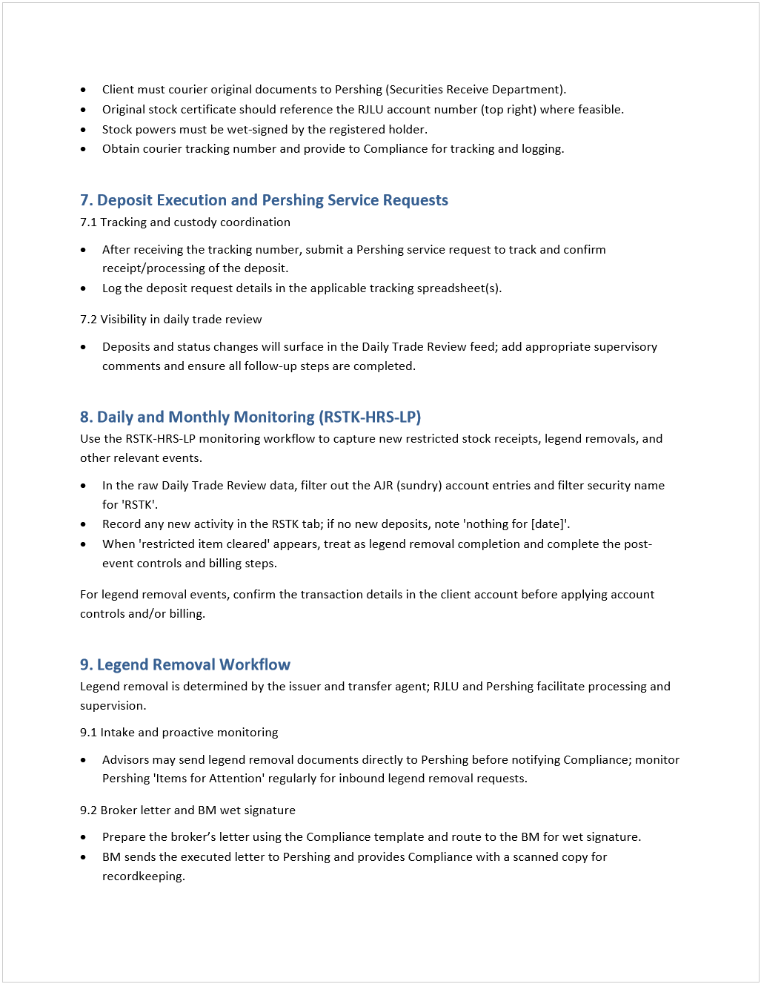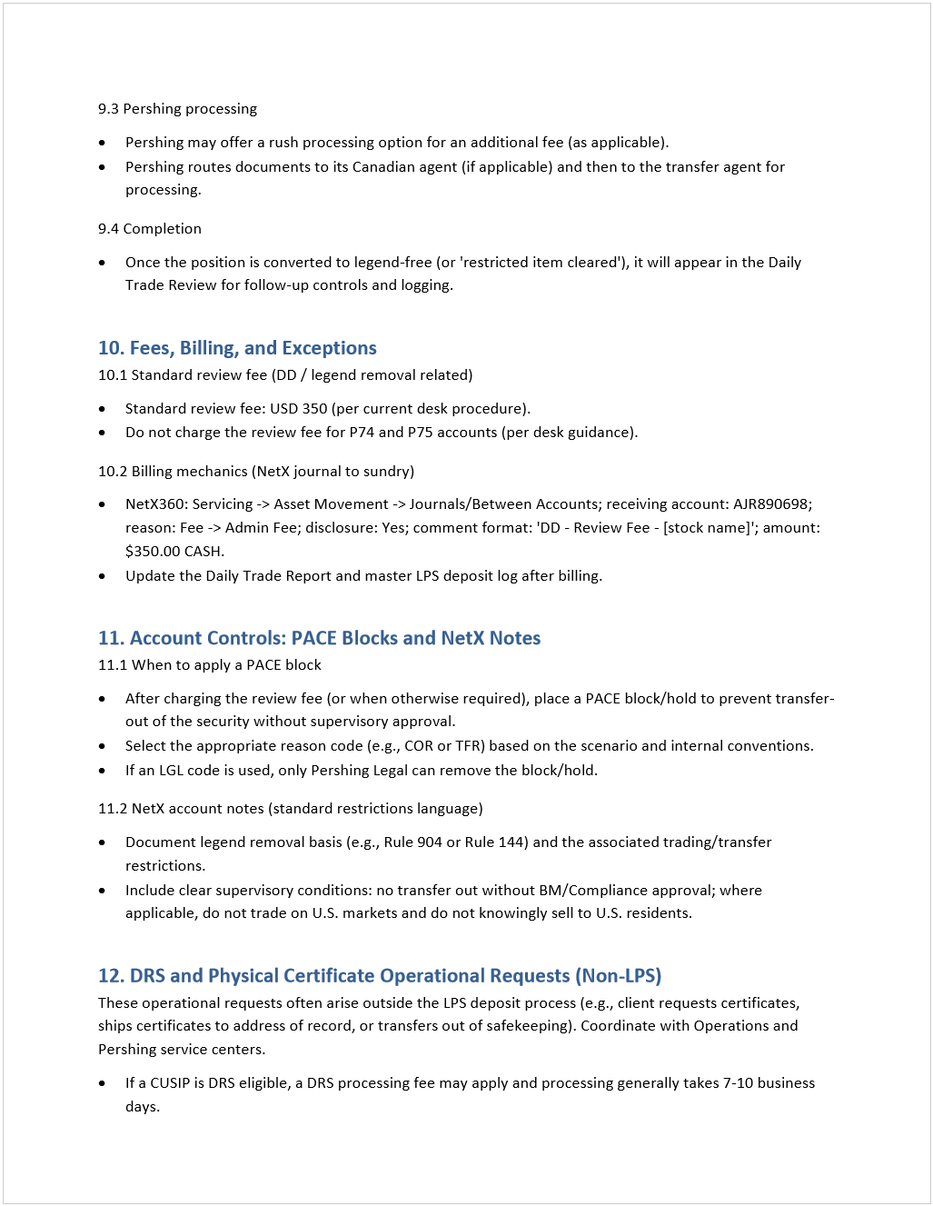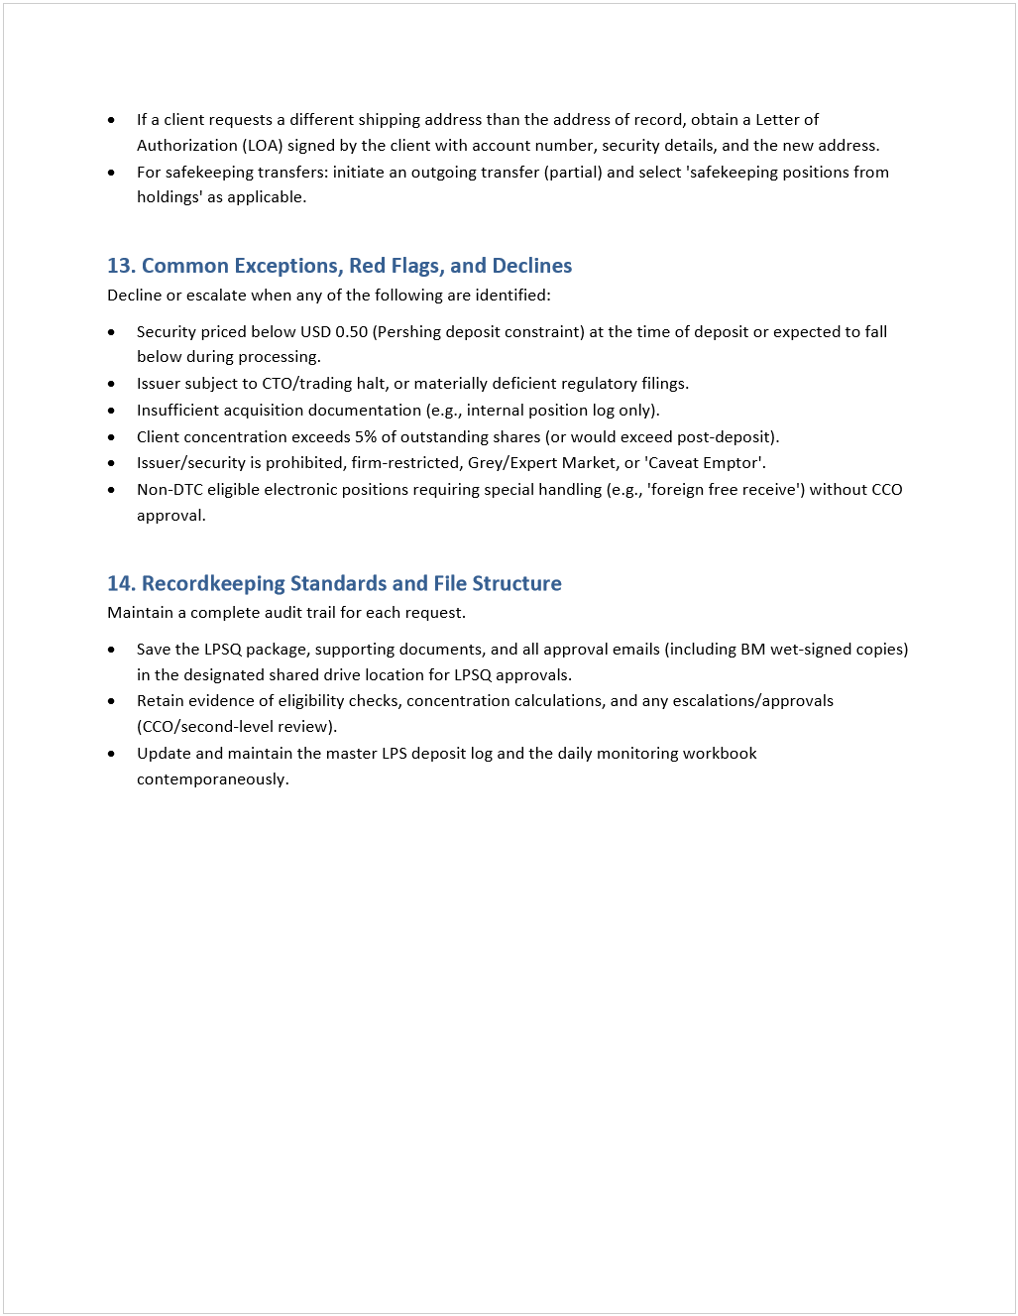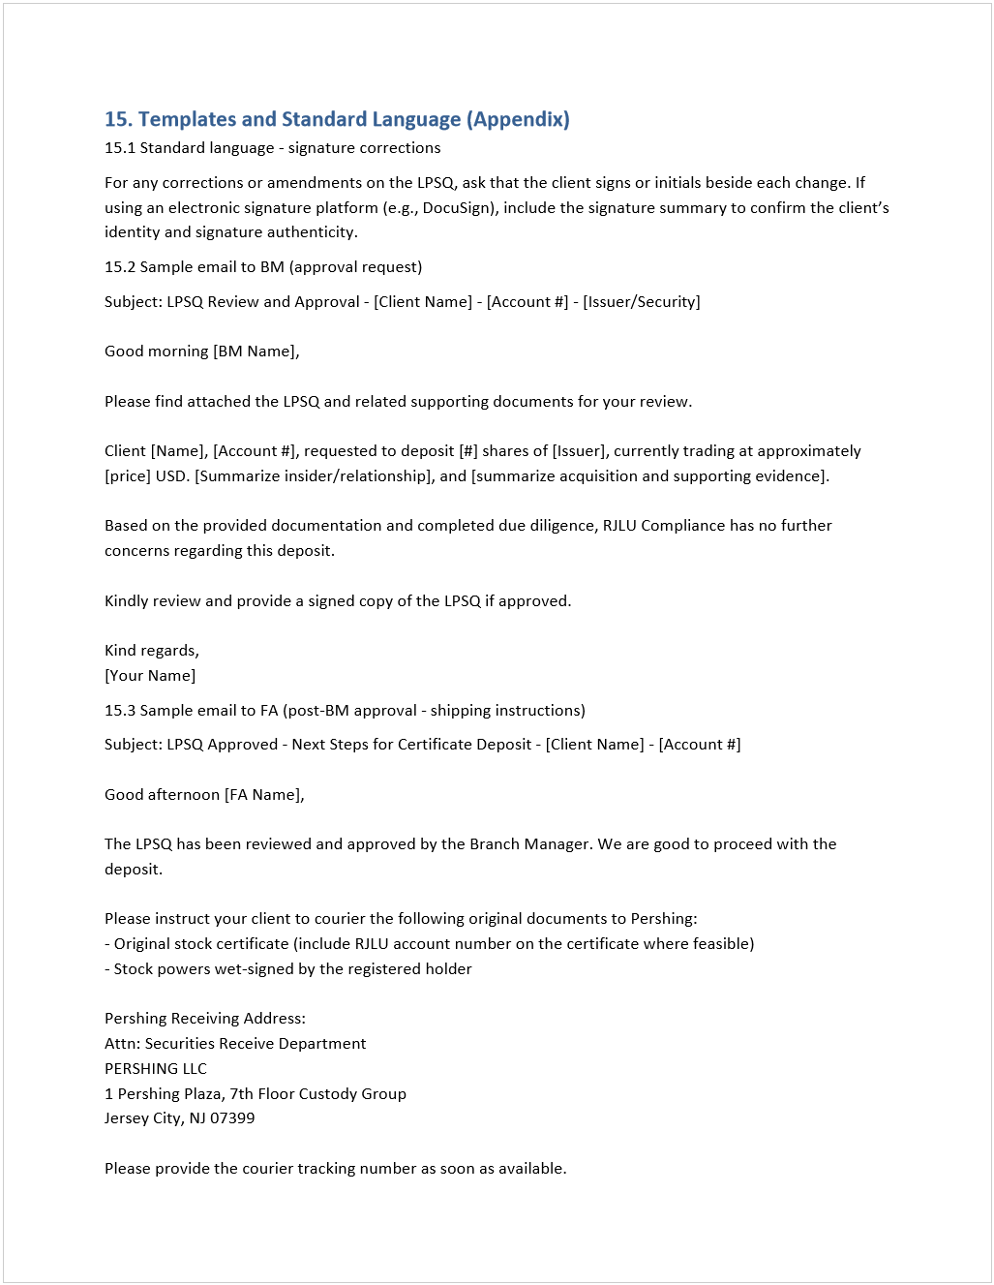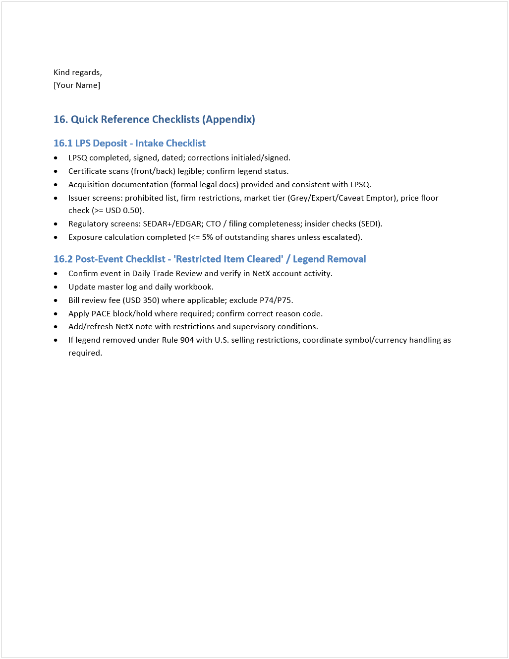

Rule 144 US Counsel Explanation
December 3, 2025
12:31 PM

Thank you for the introduction, Zafar. I see from the information provided that that there are three different tranches of shares: 7,000 shares issued on January 2, 2024, 40,000 shares issued on May 5, 2025, and 10,000 shares with no documentation indicating the issue date. I note that the physical stock certificates are all dated August 19, 2025. In order to assess the available exemptions to facilitate a legend removal and/or share transfer, please provide the original issue date of the tranche of 10,000 shares. In addition, I need to know whether Mr. Morton is an affiliate of Yangarra. Specifically, I need to know whether he is a director, officer or owner of 10% or more of any Yangarra class of voting capital stock. Also, it would be helpful to understand if Mr. Morton is intending to sell these shares, or if he is only trying to remove the legend to facilitate depositing the shares in a brokerage account.

Under U.S. law, Rule 144 promulgated under the Securities Act of 1933 only permits legend removal that is not in connection with a sale or transfer of the subject securities if the shares have been owned for at least 12 months and the holder is not an affiliate. In this regard, the tranche of 7,000 shares issued on January 2, 2024 have been held for at least 12 months and we could issue an opinion to remove the legend if Mr. Mortan is not an affiliate of Yangarra. However, the tranche of 40,000 shares issued on May 5, 2025 have not been held for at least 12 months and therefore would not be eligible for legend removal under Rule 144.

Section 4(a)(7) of the Securities Act of 1933 provides for a statutory exemption for the sale of shares that have been held for at least 90 days, subject to certain public information about the company being available and only if the purchasers qualify as accredited investors as defined in Rule 501 of the Securities Act of 1933. As a public reporting company in Canada, Yangarra satisfies the public information requirements of Section 4(a)(7), so we could issue an opinion to remove the legend with respect to the 40,000 shares in connection with the sale of the shares to an accredited investor. Such opinion would only apply to a specific sale to a specific purchaser whose accredited status was confirmed, and the purchaser would receive the shares subject to the same restrictive legend.

Treatment of the tranche of 10,000 shares will depend on the original issue date and whether the Rule 144 or Section 4(a)(7) exemptions are available.

Response

Thank you for this additional information. Unfortunately, because he sits on the board, he is an affiliate of the company and the legend cannot be removed for as long as he remaina an affiliate and for a period of 90 days thereafter.

Although legend removal is not available to affiliates, he would still be able to sell the shares immediately to accredited investors in the US (in reliance on the 4(a)(7) exemption) or in offshore transactions that occur outside of the United States where the purchasers are neither US citizens nor US residents (in reliance on the Regulation S exemption). After any shares have been held for at least a year from the original issue date, he would be able to sell shares in reliance on the rule 144 exemption, but could not sell shares in an amount that exceeded one percent of the total outstanding shares of that class in a 90 day period and only if there was current public information about the company available (principally, its most recent annual and quarterly financial statements). The legal opinion for the legend removal under rule 144 in this circumstance would be specific to the transaction and woukd have to confirm the conditions of the exemption were met at the time of such transaction.

Best Execution
Thursday, March 12, 2026
10:59 AM

Department: Compliance
Purpose: To ensure the firm meets its obligations under FINRA Rule 5310 (Best Execution), including monitoring execution quality, identifying deviations, escalating concerns, and documenting oversight.

1. Regulatory Background
1.1 FINRA Requirement
FINRA Rule 5310 requires brokers to take reasonable steps to obtain the most favorable overall execution outcome for clients across all orders (price, speed, likelihood of execution, etc.).
1.2 SEC Rule 606
SEC 606 requires public disclosure of order routing practices, including execution venues and price improvement statistics.

2. Business Context
- The firm executes orders through RJLU + Pershing (service provider).
- The broker provides the order flow; Pershing uses its own routing algorithms to seek the best possible price improvement.
- Clients benefit through:
  - Better execution price
  - Faster execution
  - Higher fill rate probability
- Pershing executes billions of trades daily and uses quantitative/high-frequency analysis to improve routing.

3. Oversight Objective
Compliance must monitor:
- Price improvement performance
- Execution quality trends
- Significant deviations or outliers
- Pershing’s ability to deliver best execution
We track percentage of orders achieving price improvement.
Normal threshold: ≥ 95%.
Any sudden deterioration or abnormal spike must be investigated.
Deviation Rules
- If results drop by 10–15%, escalate for review.
- If results suddenly jump from below-threshold back to 100%, request explanation from Pershing.
- Identify significant drops and document rationale.

4. Data Sources
4.1 Data Source #1 – SEC 606 / Route Disclosure (Pershing)
Pershing provides downloadable data:
- Go to https://www.orderroutingdisclosure.com/
- Navigate to:
1-Compliance → Policies & Procedures folder
- Search for: “RAYMOND”
- Export the report in Excel (.xlsx).
- Save report to:
R:\1 - Compliance\Best Execution\Rule 606 Disclosure
You may provide the exported file to Copilot if you need automated analysis.

4.2 Data Source #2 – NETX Execution Quality Scorecard
- Log in to NETX
- Navigate to:
Tools → Resources
- Search: “Execution Quality Scorecard”
- Enter the data into:
Excel: Best Execution Workbook
Located at:
R:\1 - Compliance\Best Execution

5. Quarterly Review Process
5.1 Collect Data
- Download and save updated SEC 606 data (Source 1).
- Retrieve execution scorecard metrics from NETX (Source 2).
- Populate the Best Execution Workbook with both sets of data.
5.2 Use the Best Execution Matrix
- The matrix checks for:
  - Outliers
  - Trending declines in price improvement
  - Any deviation of 10–15%
- Run the matrix every quarter in:
R:\1 - Compliance\Best Execution
5.3 Identify Exceptions
If any of the following occur, trigger review:
- Price improvement < 95%
- Deviation of 10–15% +
- Sudden jump to 100% after a deviation
- Significant unexplained drop in performance
5.4 Escalation
If deviations are detected:
- Notify Compliance Manager.
- Contact Pershing for explanation.
- Document Pershing’s response.
- Save correspondence in:
R:\1 - Compliance\Best Execution\Correspondence

6. Documentation Requirements
- Maintain all analysis in:
R:\1 - Compliance\Best Execution
- Archive SEC 606 data each quarter.
- Save updated scorecards and deviation matrix.
- Record findings and exception notes inside:
  - Best Execution Workbook
  - Quarterly Compliance Committee Package
- Store the finalized procedure in:
Training & Onboarding Folder

7. Deviation Matrix Calculation (5%)
Purpose:
To quantify and highlight meaningful variance from expected price improvement performance.
Procedure:
- In the Best Execution Workbook, find the column containing Price Improvement %.
- Calculate the deviation from baseline:
Deviation % = (Current Quarter – Baseline) / Baseline
- Highlight deviations ≥ 5%.
- Flag deviations ≥ 10–15% for escalation.
- Document all deviations in the Quarterly Summary Tab.

Portfolio Review
Thursday, March 12, 2026
11:17 AM

<<Portfolio Review_Procedure.docx>>

Email Monitoring
Thursday, March 12, 2026
11:17 AM

